**PRINTING TO THE OKI C5500N PRINTER**

***Instructions for Mac OS X.7+***

1. **Uninstall the C5500 printer if you have not already done so.**
   1. **System Preferences > Printers & Scanners > “-“**
   2. **OR, reset your printer drivers by holding ctrl+opt and clicking “+”**
2. **Install the OKI C5800Ldn drivers from the OKI website.**
   1. **Go to**  <http://my.okidata.com/pp-C5800Ldn.nsf?opendatabase>
   2. **OR, go to okidata.com > find drivers > Color printer > C5800Ldn and select your operating system**
3. **Open up a print dialog (Fig. 1)**
   1. **Do NOT open up Printers & Scanners from System Preferences**
   2. **This can be accomplished by opening up any program, like Adobe Reader, and hitting cmd+p**
4. **Click the Printer drop-down menu > “Add Printer…”**
5. **Find the OKI-C5500-34E56C under Default and highlight it (Fig. 2)**
6. **Click on the Use drop-down menu > “Select Software…” > Find the OKI C5800 driver and add it. (Fig. 3)**
7. **Add your printer.**
8. **Print like a maniac.**

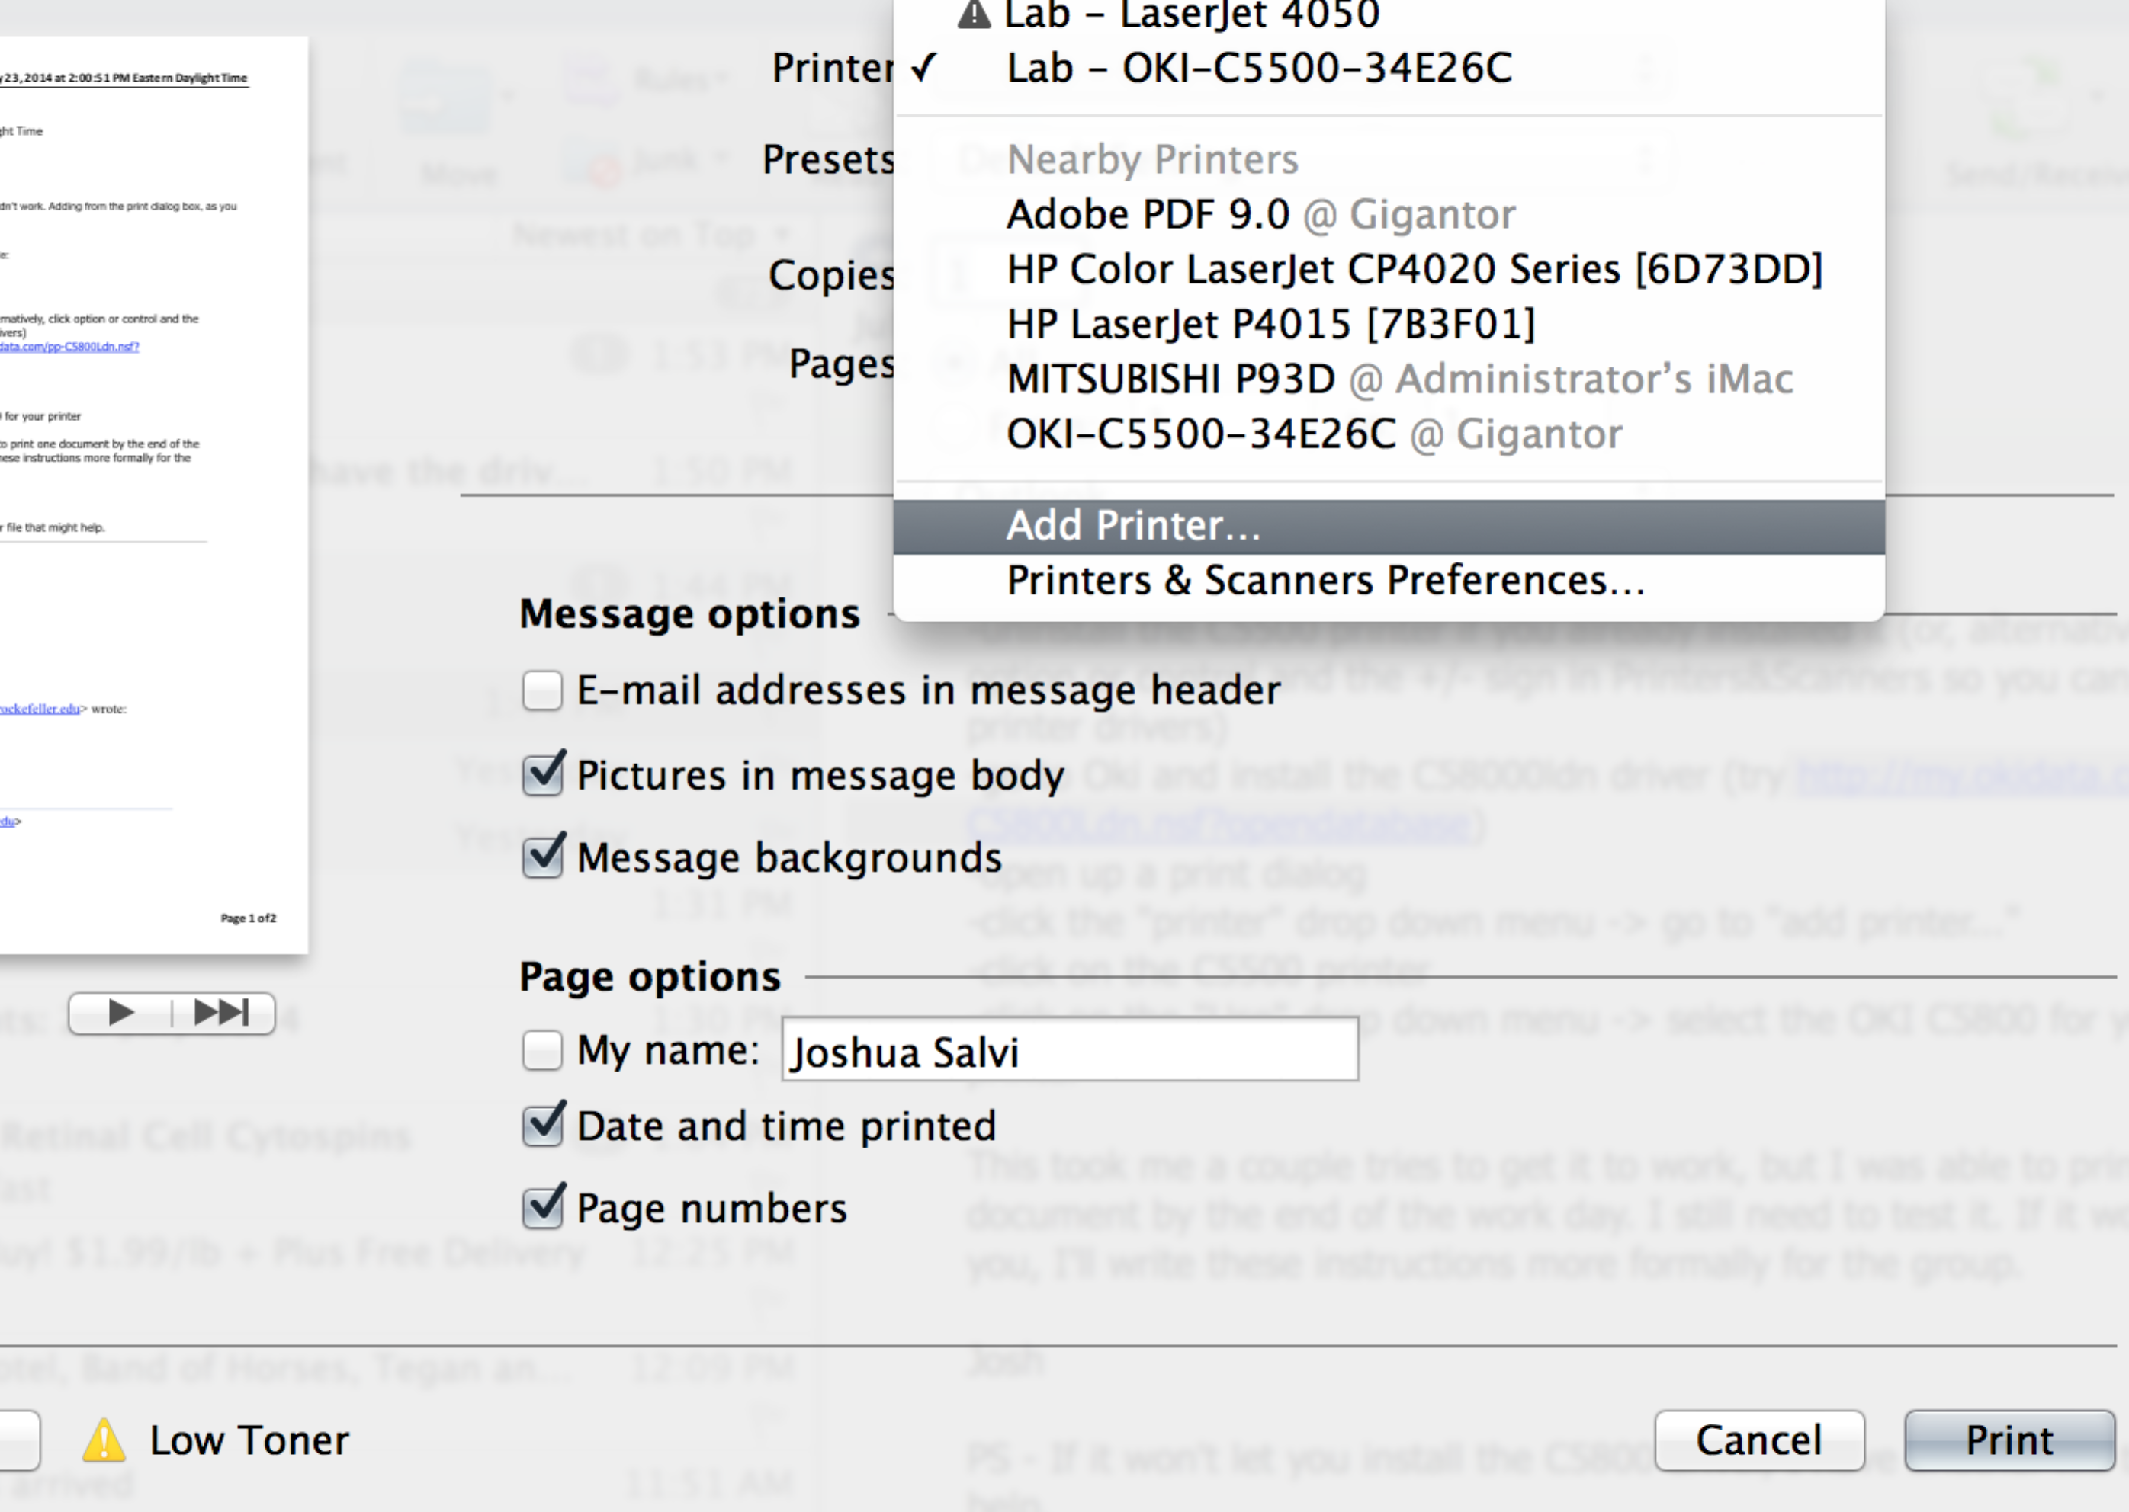

**Figure 1. Print dialog.**

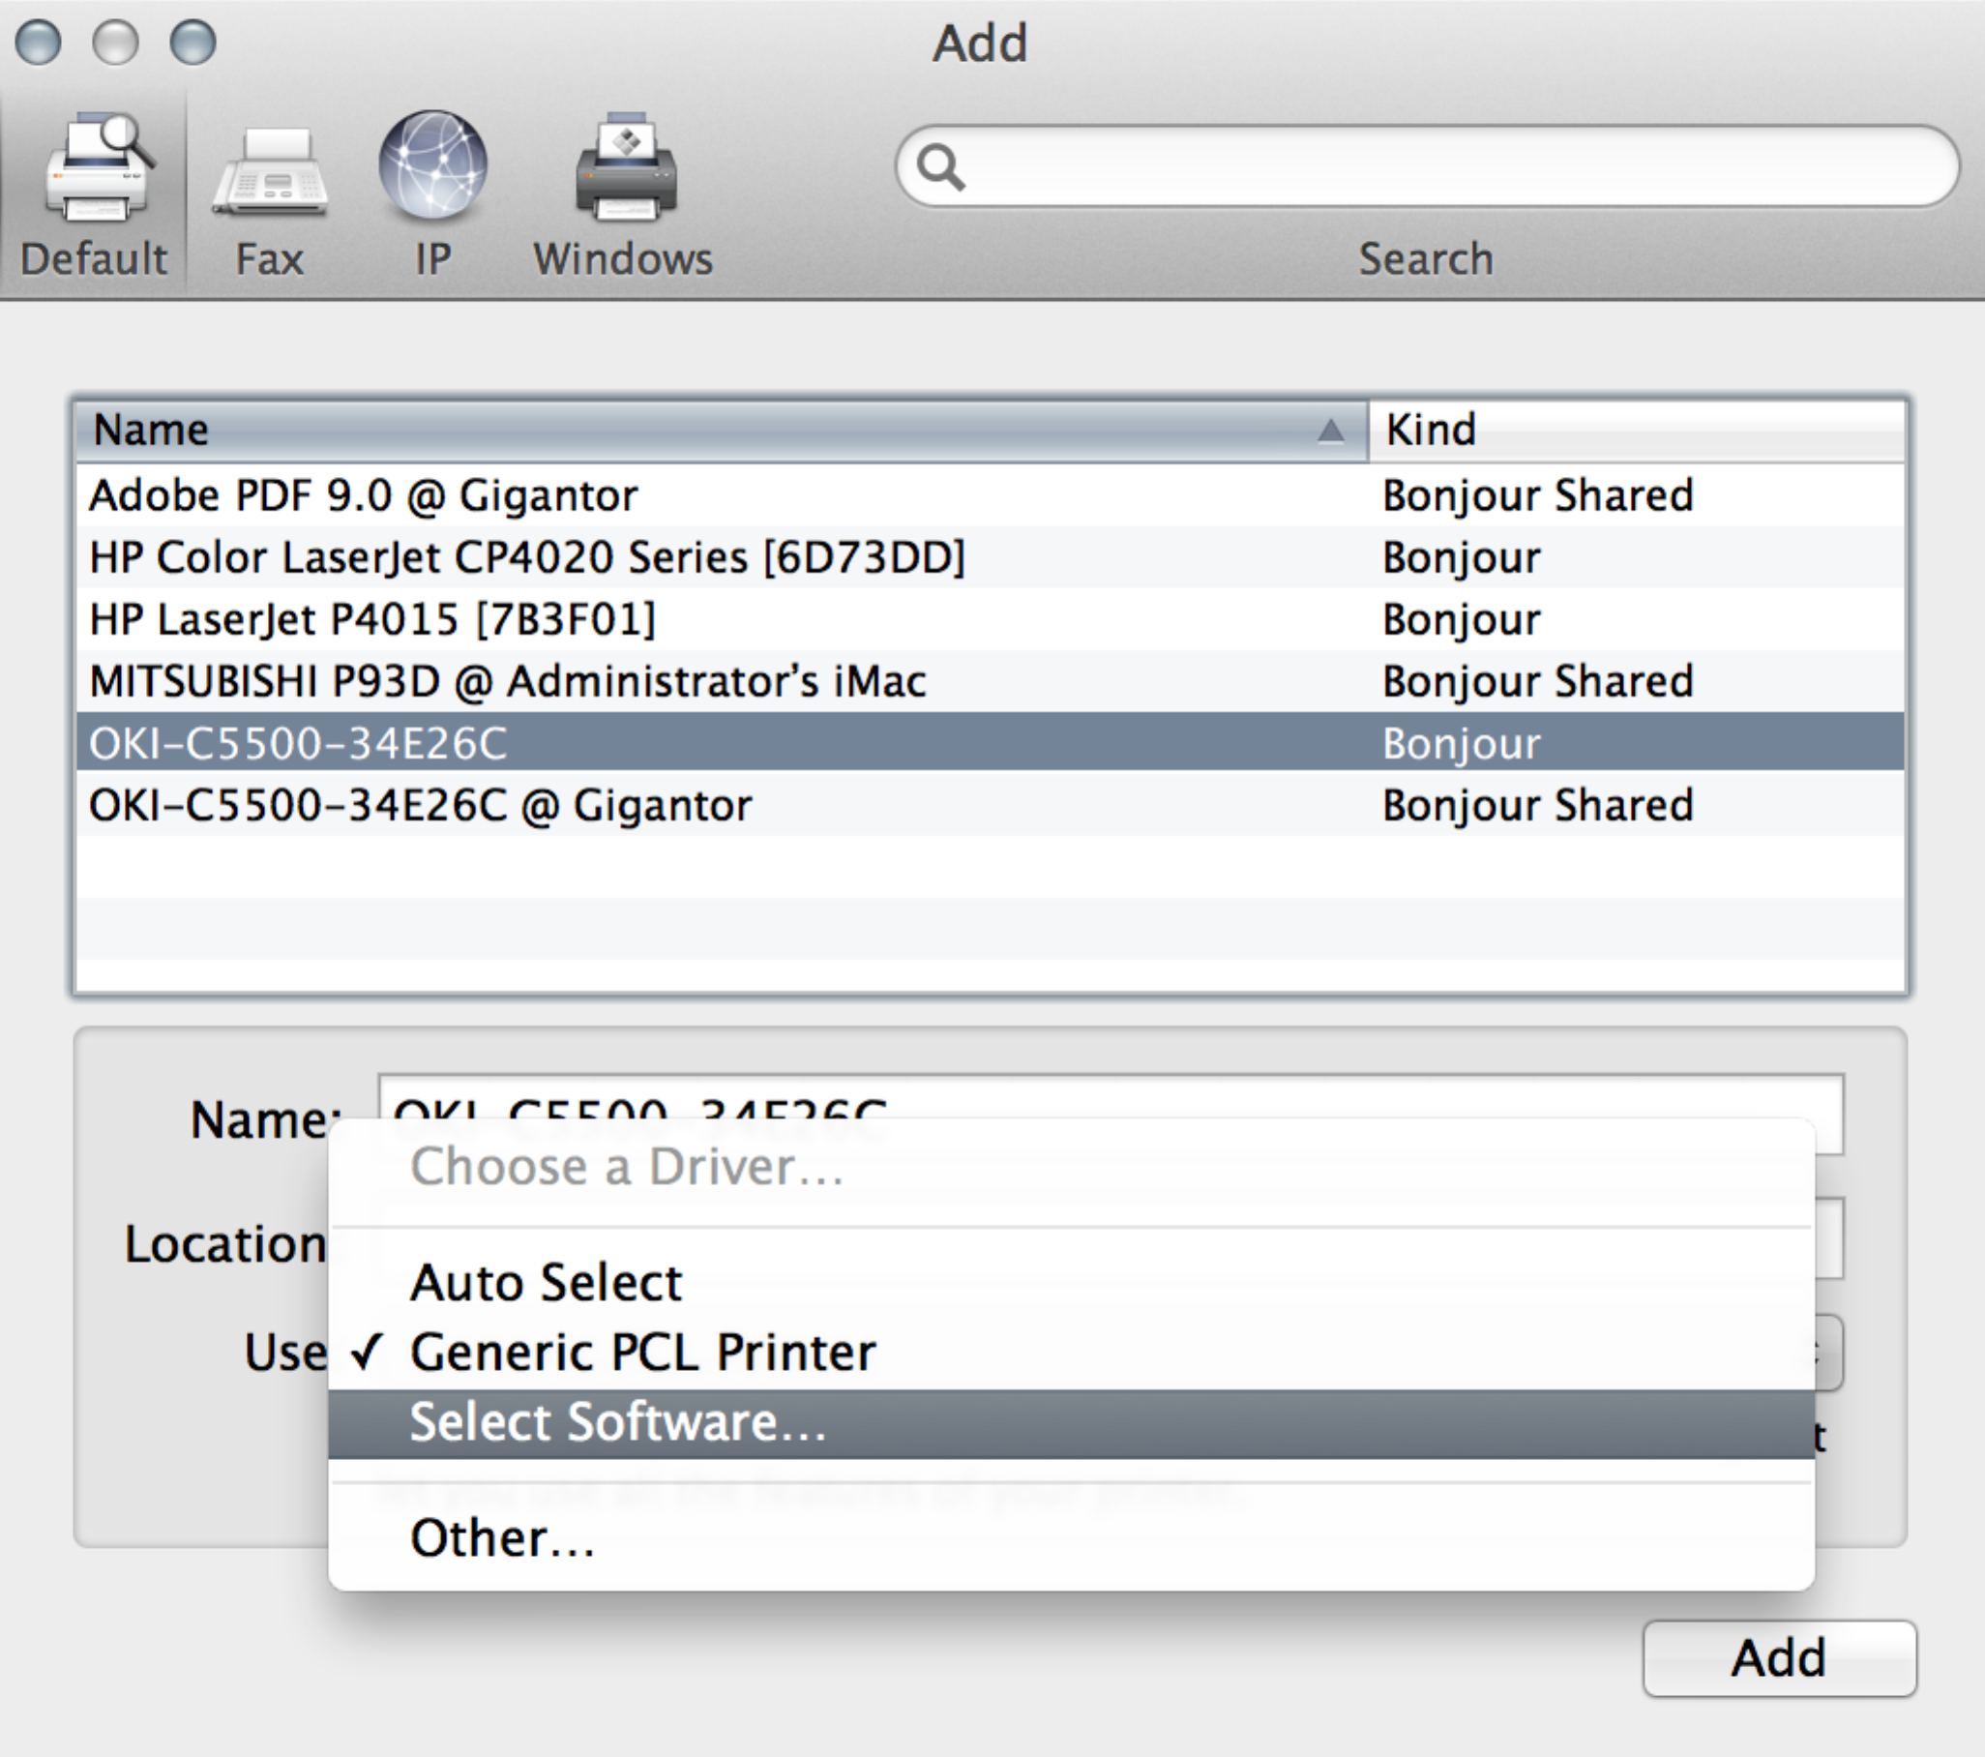

**Figure 2. Add printer.**

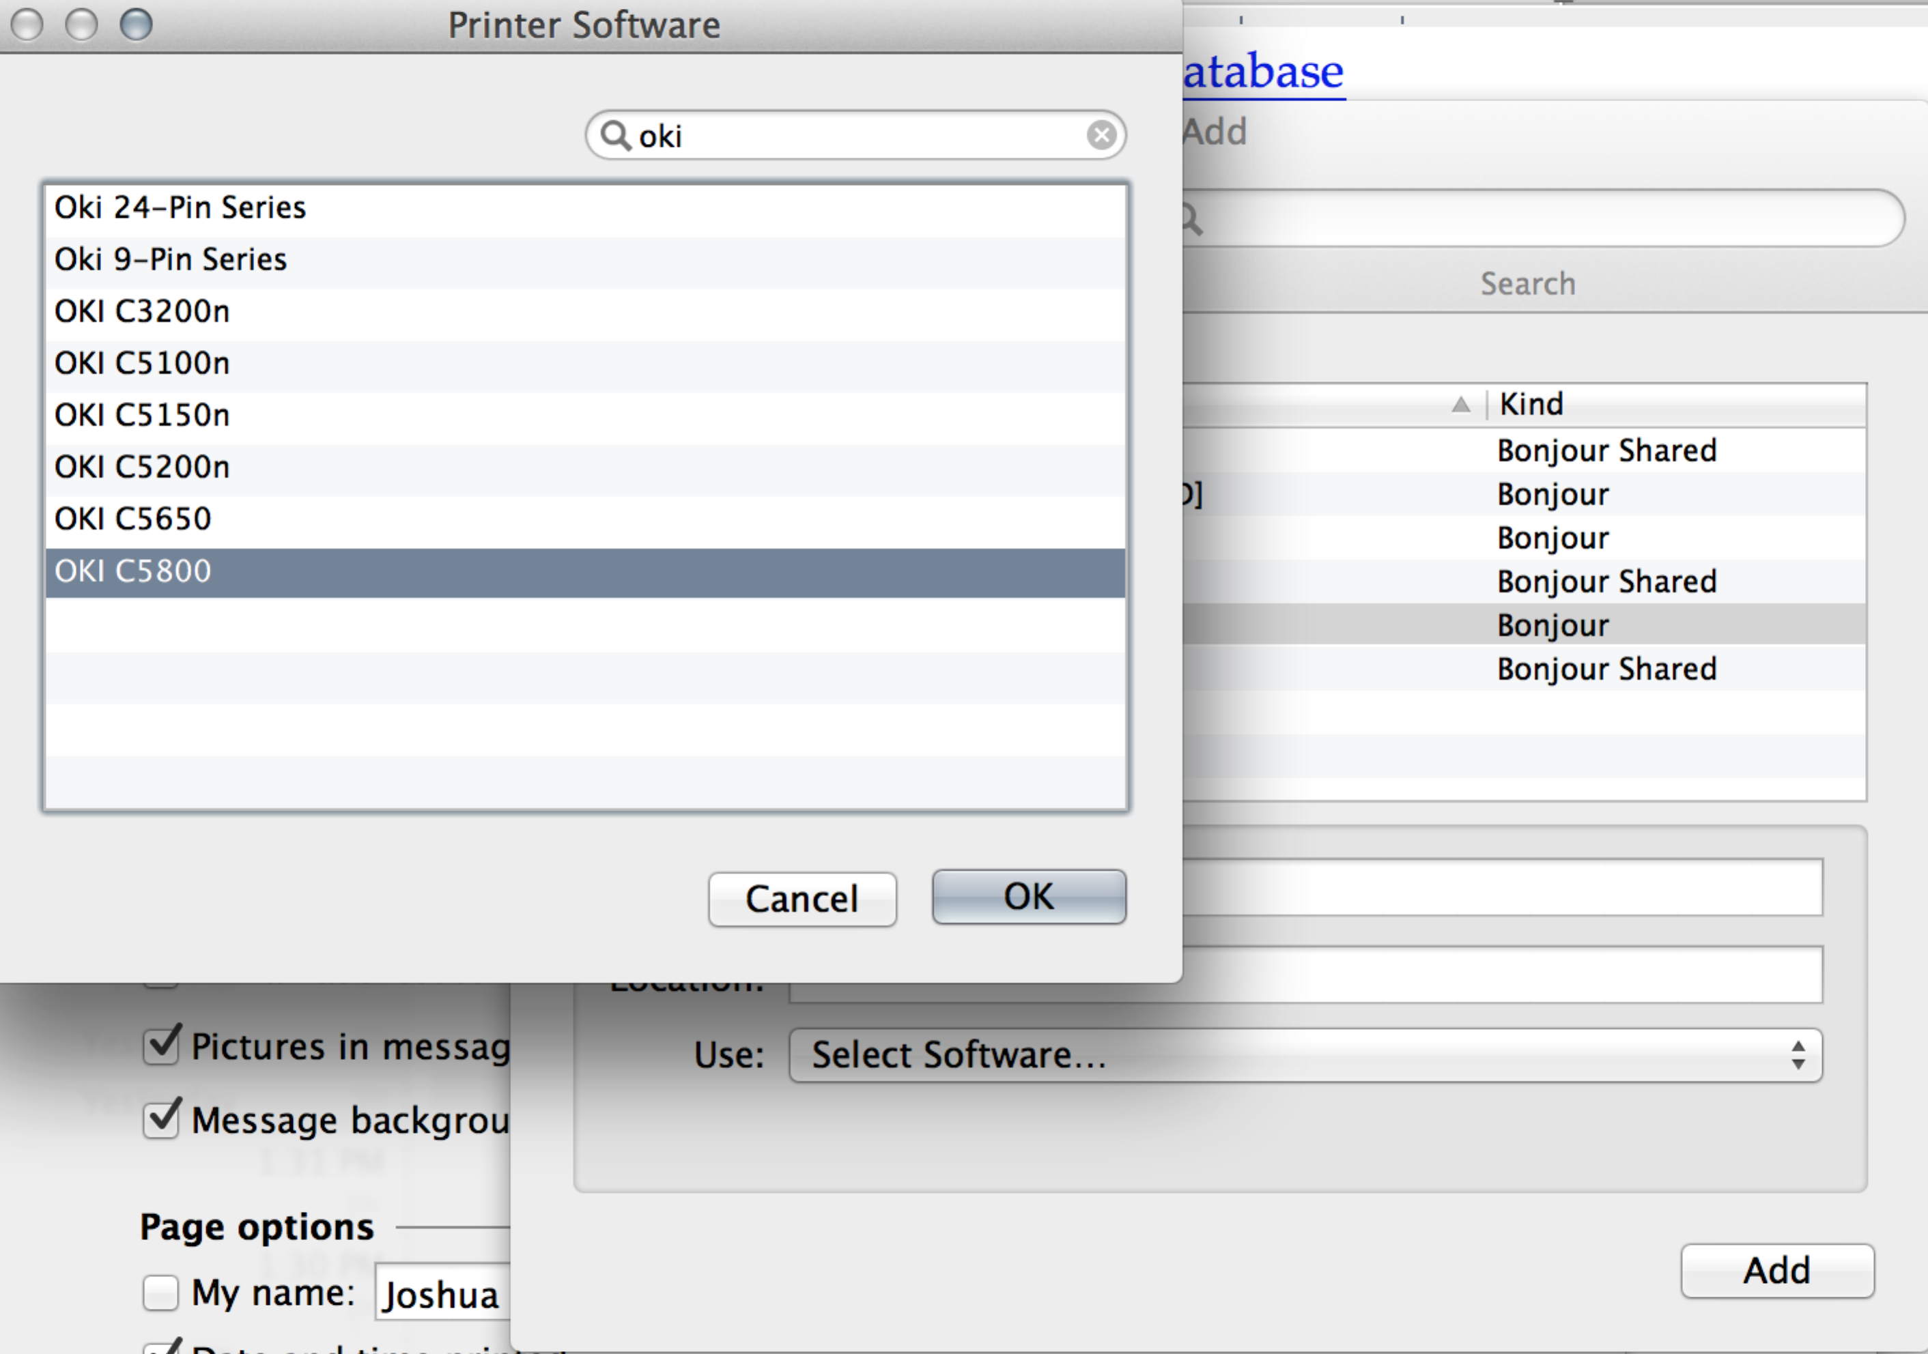

**Figure 3. Driver selection.**